DLTK's Holiday Activities for Kids  KITE CRAFT  Although this kite won't actually fly, it is a happy reminder of the times you and the kids did get to fly one.  Also check out the Kite Days poem and coloring page for a complimentary project.  Materials:  - a printer  - paper (I prefer construction paper)  - glue  - scissors  - something to colour with (optional)  - some yarn, wool or string (optional) | 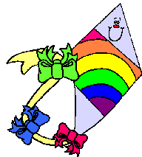

Instructions:
- Print out both template pages.
- Colour pieces, as necessary. (For a change of pace, try using different mediums than you typically do, such as paints or pastels)
- Cut out the pieces. This step may require adult assistance.
- Glue template pieces together. You can substitute real ribbons or tissue paper for the template bows.
- Cut a piece of yarn or string and attach to the kite (optional)

Templates:
- Close the template window after printing to return to this screen.
- Set page margins to zero if you have trouble fitting the template on one page (FILE, PAGE SETUP or FILE, PRINTER SETUP in most browsers).

